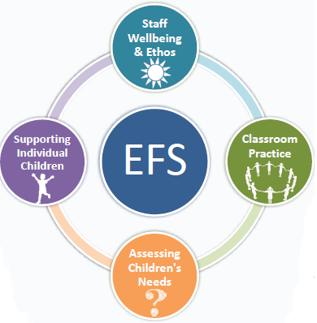

St Thomas More RC College

Town Lane

Denton

M34 6AF

27/9/2024

Dear parents/carers,

I am pleased to inform you that as a school, we are engaging in the Emotionally Friendly Settings process.

Emotionally Friendly Settings (EFS) is an initiative developed by Salford Educational Psychology Service in collaboration with schools. The aim of this process is to promote positive emotional wellbeing in school and identify and support any difficulties that arise early. The EFS process focuses on 4 key areas:



* **Staff Wellbeing and School Ethos**
* **Classroom Practice**
* **Assessing Children’s Needs**
* **Supporting Individual Children**

As part of this process we have been asked to collect data from children and staff in school to help measure the impact of this work. Children may be asked to complete a short questionnaire online or take part in small group conversations to gain their views about how they think emotional wellbeing is promoted in school. Your child’s name will not be collected and it will not be possible for them to be identified from the data gathered. Tameside Educational Psychology Service may support us with this data collection.

If you would prefer for your child to not be involved in the data collection process you are able to opt-out using the attached slip. If you do not complete the slip, it will be presumed that you are happy for your child to be involved in completing the questionnaire and for their views to be incorporated into the data collected by the school.

If you would like to find out more about Emotionally Friendly Settings, please visit the website: www.emotionallyfriendly.co.uk

If you have any further questions about the project, please do get in touch.

Yours sincerely,

St Thomas More RC College

--------------------------------------------------------------------------------------------------------------------------------

**Parent/carer’s permission for data to be collected and stored anonymously**

I am **not** willing for ………………………………… to be involved in data collection as part of the Emotionally Friendly Schools process

Parent/carer’s name ………………………………………………………….

Signed: ……………………………………….. Date: …………………………………………

Please return to the school office by: ***Friday 4th October***