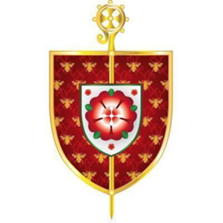
Confirmation Programme 2026
The Catholic Parishes of
Holy Family
Holy Family Presbytery, 67 Thornley Lane North
Reddish, SK5 6QR
(0161) 223 2930

St Joseph’s
St Joseph’s Presbytery, 23 Gorton Rd
Reddish, SK5 6AZ
(0161) 432 2168

St Mary & St John Fisher
St Mary’s Presbytery, Duke Street, Denton, Manchester, M34 2AN
(0161) 336 2358

This year to prepare for the Sacrament of Confirmation we are clustering three parishes together.

To register on the preparation programme, your child must be baptised Roman Catholic and have received the Sacraments of Reconciliation and First Holy Communion. Please fill in the application form (including which parish you live in) and

return the form to you OWN PARISH PRIEST IN YOUR OWN PARISH: BY Friday 6th March
Fr Joe Gee, St Mary & St John Fisher, Denton;
Fr Peter Hapgood-Strickland, Holy Family, Dane Bank;
And Fr Damien Louden, St Joseph’s, Reddish.
You must provide evidence of your child’s Baptism. If your child was baptised in one of our parishes, please indicate that on the application form. If your child was baptised elsewhere EVIDENCE of baptism will need to be provided from church of baptism.

The Catechetical sessions will take place in the parish hall at St Mary’s church hall, Market street, Denton on

Saturday 18th and 25th April from 9.30am to 2.30pm (Children will need to bring a packed lunch).

BOTH SESSIONS must be attended. As well as regular attendance at Weekend masses (Saturday Vigil or Sunday Morning).

Bishop John has agreed to come to St Mary's Church on 10th June 2026 at 7pm to confer the Sacrament of Confirmation on our young parishioners currently in Year 8 (and indeed any older pupils that wish to be Confirmed but missed previous years).
We look forward to accompanying our youngsters on this next step along their Journey of Faith and hope parents will also support and encourage them to receive this wonderful Sacrament.

God Bless
Fr Joe, Fr Peter and Fr Damien

